Vol. 20 No. 4 Touch of Heaven Ministries
Torch & Trumpet
October - December 2018
THE NUMERAL THREE
(A Biblical Number of Great Importance)

A couple Sundays ago instead of listening to the sermon, I confess, the Lord showing me the many 3s in His Word. I finally decided to investigate this. In the heavenly Hebrew language every letter of the alphabet and number has meaning and the third Hebrew letter Gimmel is assigned the numerical value of 3. Gimmel follows the first letter, Aleph (1), and the second letter, Bet (2). The number 3 is defined as “divine completeness” and “perfect testimony.” Divine completeness points most clearly to the Triune Godhead: (1) God the Father, (2) God the Son and (3) God the Holy Spirit. But there is far more. “In the Talmud it is said that the Gimmel symbolizes a rich man running after a poor man (the next letter Dalet) to give him tzekaah (charity).” The Godhead has been running after failing mankind since the beginning. The Father (Aleph) has been running to His prodigals since the first sin. The Son, Jesus (Bet), came as mankind’s Redeemer from sin (Jn. 4:24) for Yeshua (the Hebrew of Jesus) “represents judgement and recompense (i.e. the Avenger of blood called go’el haddam).” Note the “g” of go’el is Gimmel which sounds like the “g” in girl. Also, Aleph (1) and Bet (2) together equal Gimmel (3) just as 1 + 2 = 3. This is “suggesting that Gimmel (3) represents the Holy Spirit proceeding forth from the Father (Aleph) and the Son (Bet)” to do 3 things: convict us of (1) sin, (2) our righteousness and (3) the judgement to come (Jn. 16:8). Overall, Gimmel (3) is considered a picture of God’s grace. As the Representative, Ambassador of Jesus, the Holy Spirit knocks on the door of our hearts that we might repent and be saved.
Now let’s look at some of the 3s of the Bible. On day 3 of creation, God separated the void into 3 primary portions of our habitat: (1) land, (2) sea and (3) atmosphere. Later we will find that God also created 3 heavens: (1) Earth’s atmosphere, (2) the universe (3) the Heaven of God’s throne (2 Cor. 12:2). On the sixth day (2 X 3) the Godhead created and made the 3 portions of mankind and then placed them together (Gen. 2:7). Only humans were made triune: (1) a spirit with (2) a soul living in a temporal physical (3) body. The third son of Adam and Eve was Seth. His name means “the appointed.” It will be out of his line that Messiah shall come. Noah had 3 sons whose families shall repopulate the earth after the global flood. And there are more 3s.
God chose a nation for His family by the faith of 3 generations of a former Syrian family from Ur: (1) Abraham, (2) Isaac and (3) Jacob/Israel. There were 3s in the dreams of the baker (3 baskets) and butler (3 branches) which they shared with Joseph while he was in prison. On the 3rd day of Pharaoh’s birthday he decided their fate exactly as Joseph had said (Gen. 40) and Joseph’s dream of rulership was later fulfilled also (Gen. 37). Then 430 years later the descendants of the Abraham will be rescued as slaves from Egypt. An Angel of Death shall pass over their homes, but they will be spared if they take the blood of a lamb and strike in onto the 2 side posts and the 1 upper post of their doors (Exod. 12:7). [Similarly, Jesus, The Lamb of God, will die on the cross at the ninth hour (3 pm), the same hour the Passover lambs were then slaughtered (Matt. 27:45-50). After the Israelites were rescued from slavery, they will be joined in matrimony to Father God by the Old Covenant cut at Mt. Sinai (Exod. 19-20), and Jehovah shall call His wife or covenant people to gather together collectively to seek Him 3 times every year. They were to keep the 3 Feasts of the LORD: (1) Passover or Pesach, (2) Pentecost or Shavuoth, and (3) Feast of Tabernacle or Sukkot or Succoth (Lev. 23). Then the Tabernacle of Moses (TOM) was built, and 3 tribes camped on each of its four sides. This original sanctuary to worship God had 3 areas or depths of interaction with God: (1) the Outer Court, (2) the Holy Place, and (3) the Most Holy. Most of these 3s confirm the definition of “divine completeness” yet there are many more.
There are also 3s which confirm the definition of “perfect testimony” or witness. It only takes two or 3 witnesses to establish the truth (Deut. 19:15, Jn. 8:17). That is why there are so many 3s. “Three men” i.e. the LORD and 2 angels, visited Abraham before the destruction of Sodom and Gomorrah (Gen. 18). God named the 3 greatest OC witnesses of Him from His perspective as (1) Noah, (2) Daniel, and (3) Job (Ezek. 14:4). A great witness of our God as the one true God was recognized by Neb when a fiery furnace did not harm Jehovah’s 3 faithful followers: (1) Shadrach, (2) Meshach, and (3) Abednego (Dan. 3:28). A perfect witness of Jesus being the promised King, Prophet and Redeemer (Num. 24:17) was clear by the 3 gifts of the Magi: (1) gold, (2) frankincense, and (3) myrrh (Matt. 2:11). Jesus took His dearest 3 disciples on the Mount of Transfiguration to later give witness (1 Peter 1:16.) when Jesus interacted with 3 persons: (1) the Father from within His shekinah, (2) Moses and (3) Elijah (Mk. 9). John also shared what was called the perfect “witnesses to the deity of Christ.”
Jesus Christ is He who came with water and blood not with water only, but with the water and with the blood. And it is the Spirit who gives testimony—because the Spirit is Truth. For there are three that give testimony—the Spirit, the water, and the blood; and there is complete agreement between these three. (1 John 5:6-7 WEY)
John also seems to agree with Paul who wrote of Jesus’ 3 deaths: (1) the death of His soul in Gethsemane, (2) the death of His spirit when He took on our sin, relinquishing His spirit in our place, and finally (3) the death of His physical body (Phil. 2:8). All 3 deaths were one (in unity) to save the lost, resurrecting and giving eternal life to all who believe (1 Jn. 5:7). Like Jonas 3 days in the fish, Jesus was 3 days in the earth (Matt. 12:40). And from our Savior’s obedient sacrifice for us, He was exalted by the Father (Phil. 2:9) so that unto His Name every knee must bow of (1) human beings, (2) angelic beings, and (3) demonic beings (Phil. 2:10) which is also a “perfect testimony” or witness of His victory over (1) sin, (2) death and (3) the devil as well as His authority and power which He shares with the Church. It appears the number 3 is very important to God. And these are only a few of 3s in scripture.
There is one issue that will never be divinely completed (3). In was in the beginning 3 but then destroyed. What? There were 3 archangels or cherubs each one in charge of 1/3 of the angels: (1) Lucifer led the angelic singers, (2) Michael led the angelic warriors and (3) Gabrielle led the messenger angels. But Lucifer (Satan) fell with pride along with his 1/3 of the angels. No one will change this. This explains why there was only two cherubim on the veil and only two cherubim placed upon the Ark over the Mercy Seat. There should have been 3. Only Michael and Gabrielle remained in service unto God. That confirms the importance Israel’s and the Church’s ministry of thanks, praise and worship that Satan. That is why Satan so despises us for taking over his role and why rebuilding the Tabernacle of David (TOD) is important. The TOD is one of two very important issues that have not been divinely completed (3) yet. But I believe they will be soon. In the Old Testament we find the original place of worship to God was a mobile tent sanctuary going wherever Israel went. This Tabernacle of Moses (TOM) was a pattern of ministry unto God provided for both covenant people: Old Covenant (OC) people (Israel) fully and New Covenant (NC) people (Church) in part. Their ministries unto God will differ.
The Church has an unfinished NC ministry unto God as His priests (Rev. 1:6). It is connected to only one furnishing, the Ark, which was meant to be in the Most Holy of the TOM, but it was removed. The TOM became Ichabod—God and His glory departed after the sins of the priests Eli and his sons. The Ark, God’s throne on earth, was never returned to the TOM. Instead it was placed by king David (a type of NC believer) in the prototype of our NC Ministry called the Tabernacle of David (TOD). This tabernacle was a simple tent pitched on Mount Zion with only one area, the Most Holy for the Ark i.e. the Manifest Presence of God. There were no veils to limit any one from approaching Him for it was a foresight of the veil torn by Messiah (Heb. 10:19-20; Matt. 27:51) for the Church to boldly enter before God’s throne or Presence. The original TOD was assigned with Levites singers and musicians thanking and praising God in song and singing prayers 24/7/365. That is non-stop! David (although of the tribe of Judah) and these Levites experienced God’s Manifest Presence regularly as should we now. Excessive blessings were bestowed on Israel as a nation because this ministry pleased God and still does to this day. The TOD (the prototype of our ministry unto God) continued throughout the reign of David and his son Solomon but then abruptly stopped. Solomon’s son abandoned it as did many kings thereafter though not all. There were no 3 generations to establish this ministry, only (1) David’s reign and (2) Solomon’s reign. Yet the Word of God speaks of a day when it will be rebuilt (Amos 9:11) especially with the Church (Acts 15:16-17). Other prophecies imply that it will be completed by the (3) last generation which I think includes us today! We need to start rebuilding the TOD. We may be that last generation to complete this!
Israel also has an unfinished ministry unto God by OC priests in the Temple fully patterned after the TOM. The first (1) majestic Temple was erected in the days of Solomon around 960 B.C. God blessed the nation of Israel abundantly as king Solomon kept the NC TOD ministry and OC Temple ministry both going continually. But sin grew over the future generations. It became Ichabod too and was finally destroyed by the Babylonians who also took many into captivity. But 70 years later (as prophesied by Jeremiah) they returned to Jerusalem with Ezra and Nehemiah to rebuild the second (2) Temple which was enhanced hundreds of years later by king Herod. But when Israel refused their Messiah, the second Temple was also destroyed; this time by the Romans in 70 A.D. There has been no OC priestly ministry unto God in a temple for around 1,948 years since there has been no Temple. But there will be completion soon by the (3) third Temple.
While in Jerusalem in the fall of 2017, my husband and I visited the Temple Institute which we visited first in 1979 and I alone in 1996. It has greatly expanded over the years. This time they shared the architectural plans of the (3) third Temple by a virtual video. It is magnificent, and I personally think they have already prepared every piece of the construction and are ready to assemble it as soon as Mount Moriah is available or out of Muslim jurisdiction. Why? Because they already have all the Temple instruments, furnishings, clothing for the priests, and a live red heifer in Israel. When Jesus returns as King of kings and Lord of lords for His Millennial Reign, both ministries of the TOD and a bloodless Temple shall flow together far greater than in the days of Solomon, all for our Great Lord and Messiah Jesus!

* * *

LIBERTY HOUSE OF PRAYER
As I pressed on to share the opening of Liberty House of Prayer (LHOP), the 3s did not stop. My husband, Michael, and I just finished constructing this 3rd site for rebuilding the TOD. We remodeled our double garage. It has an exterior entrance on the South side of our house with 3 areas: (1) a foyer, (2) bathroom, and (3) a 20 ft by 20 ft prayer/praise room. The room is lined on one side with 3 prayer banners made in the 1990s. On the front wall are 3 worship banners made over the last fifteen years. Our plan is to start Bible Studies and training to seek the face of God i.e. rebuild the TOD. We hope this may include you! All denominations are invited.
In preparation we will instruct and practice (1) walking in faith; healing the sick; and giving thanks, prayer and praise including singing prophetic songs (new songs) and spiritual songs to welcome His tangible or Manifest Presence, (2) practice listening, prophesying and soaking in God’s Presence to reach our maturation and destinies in Christ and (3) with aim to birth personal and collective revival. WE HOPE TO START THESE TEACHINGS ON THE 3RD WEEK OF JANUARY 2019!
Please inform us on the 3 topics which interest you the most (A, B, C etc.) and what hours work best for you. Parking in the Amtrak Station is best in the evenings and weekends, but it is dark early in the winter. Email for details: Judy@touchofheaven.org.
Topics of Teaching & Practice
A Who You are in Christ (12 lessons) Part I: King by Judy
(Authority of the Believer)
B Who You are in Christ (12 les.) Part II: Priests by Judy
(NC Ministry unto God)
C Prayer Series (9 lessons) by Judy
(Teach and Practicing Prayer)
D Healing the Sick (12 DVDs) by F & C Hunter
(Disciples Healing the Sick)
E Covenant with God (9-10 lessons) by Judy
(What It Means to be in Covenant with God)
F God’s Generals (12 DVDs) by Roberts Lairdon
(Study of Former Revivals)
G Voice of Apostles 2018 (7 DVDs)
(How to Stay on Your Destiny Path)
H Voice of Prophets 2017 (5 DVDs)
(Destiny and the Miraculous) AND MORE.
LHOP PICTURES

Foyer

Bathroom
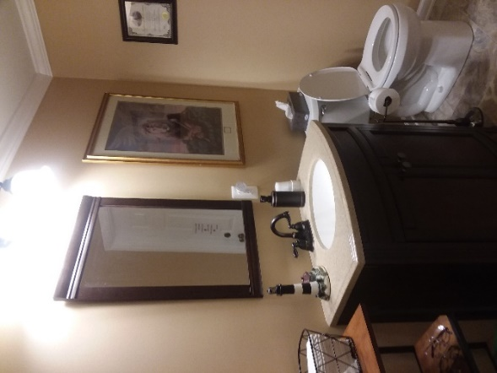

Prayer/Praise Room (3 pictures)
#1
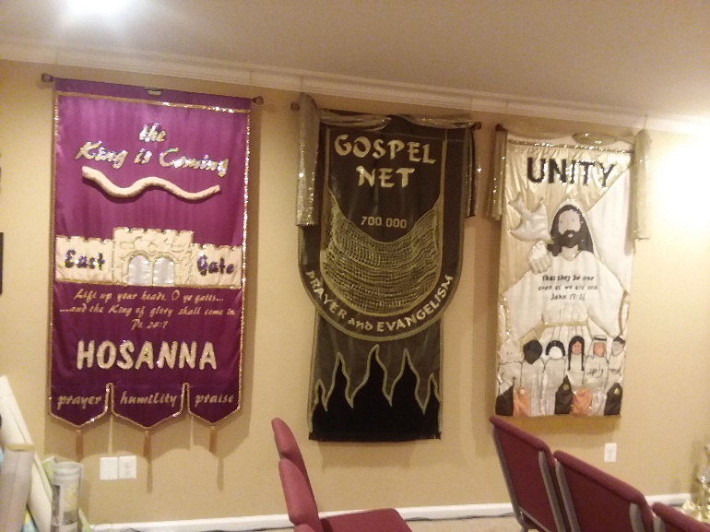

#2
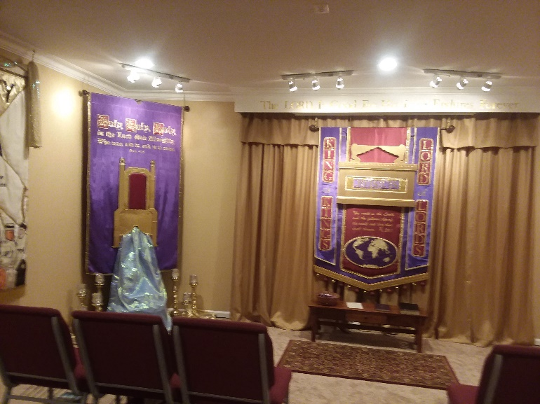

#3
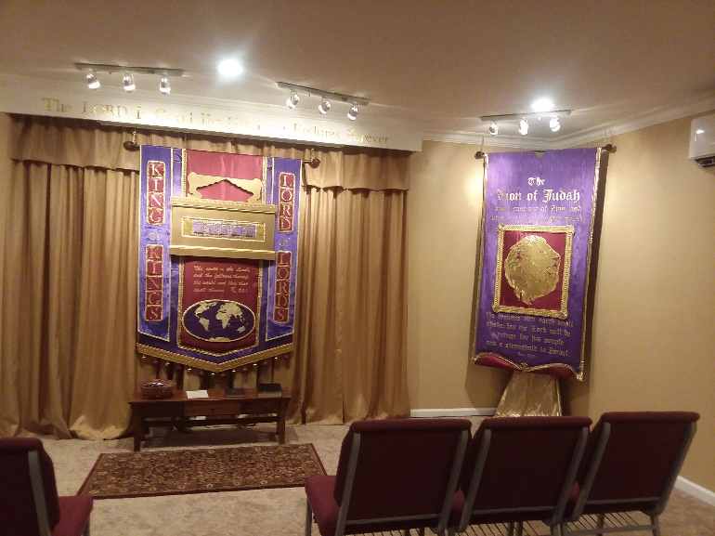

No charge for classes. Classes are free.
Some classes have study manuals which you may buy. Parking is best in the Amtrak Station in the evenings and weekends.

Email for with study preferences, our address
and directions.

Judy@touchofheaven.org

¹ Hebrewforchristians.com 2 Interpreting the Symbols and Types p. 5
Hebrewforchristian.com
Parallel Bible Commentary p. 2638.

